Policies
We offer curb to curb service. Drivers can assist passengers in safely boarding and exiting the van. Drivers cannot assist riders in getting to the van or into their place of destination.
All service is limited to destinations within Forsyth County only.
Tipping is not permitted.
Riders under the age of 18 must be accompanied by an adult.
All riders must remain seated at all times, with seat belts buckled.
No smoking, other tobacco use, eating or drinking is permitted on the vans.
Improper behavior will result in the termination of the ride and future riding privileges.
We request a minimum 24-hour cancellation notice.
Excessive no-shows or cancellations may result in the loss of riding privileges.
Due to mechanical failures, inclement weather or other unforeseeable circumstances, trips may be cancelled at any time without notice. However, we will make every effort to notify riders.
Service animals, portable oxygen and respirators are permitted and welcome.

Forsyth County
Dial-A-Ride

Forsyth County Dial-A-Ride 514 W Maple St Suite 202 Cumming, GA 30040



It’s For Everyone!
Don’t Stay Home!
Call Dial-A-Ride
770.781.2195
General Information
Dial-A-Ride is a public transportation system for use by all Forsyth County Residents. Our system is classified as “on call”. This means residents make appointments for specific trips. There are no set routes.
Appointments are made on a first come first serve basis and based on availability. Appointments are accepted up to a month in advance.
We provide transportation for medical appointments, shopping, education, personal errands, recreation etc. The system benefits the local community by promoting local business and services.
Dial-A-Ride is operated by Forsyth County Fleet Services and is funded by the Forsyth County Board of Commissioners, passenger fares and the Georgia Department of Transportation.
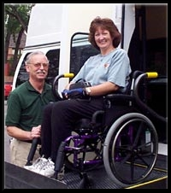
Equipment
Dial-A-ride operates eight (8) vans. All vans are equipped with wheelchair lifts.

Hours

Be independent!

Let Dial-A-Ride Get You There

It’s for everyone!

Your Trip is Our Priority

Call
770.781.2195

Passenger service is provided between the hours of 8:30 a.m. and 3:00 p.m. Monday through Friday. Rides must be booked through the dispatcher between the hours of 8:00 a.m. and 3:30 p.m. Monday through Friday by calling 770.781.2195.
Dial-A-Ride is closed on all official county holidays, as listed below:
New Year’s Day Martin Luther King Jr. Day Memorial Day Independence Day Labor Day Veterans Day Thanksgiving (2 days) Christmas (2 days)
Please call or consult the county Web site at www.forsythco.com for dates.
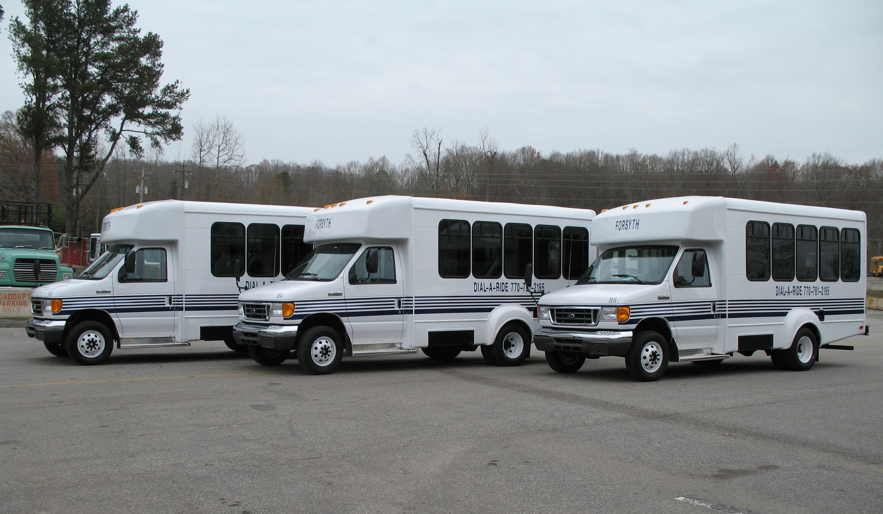
Fares
All trips (each way) including, additional stops, are $2.00 (exact change)
Unscheduled additional stops are made only if time permits.
Exact fare is required. If it is necessary for the driver to stop for a passenger to make change, the additional stop fare will be charged.

